# User Manual

Version 1.0

**Group: Siddarth Reddy Chinthalapani – 2845810**

**Pramodh Bakkera – 2834840**

**Ram Prasad Gummadi - 2873418**

Table of Contents

1. Introduction 1

1.1 Overview 1

2. Getting Started Terminology 2

2.1 Set-up Considerations 2

2.2 User Access Considerations 2

2.3 System Organization & Navigation 2

2.4 Exiting the System 2

3. Using the System Pages 3

3.1 Register Page 3

3.2 Login Page.......................................................................................4

3.3 Review Page....................................................................................5

4. Troubleshooting & Support 6

4.1 Error Messages 6

4.2 Special Considerations 6

4.3 Conclusion.……………………………………………………………………………….6

List of Figures

**No table of figures entries found.**

|  |  |  |
| --- | --- | --- |
| **FIGURE_NO** | **NAME** | **PAGE No** |
| Fig 1 | Register Page | 3 |
| Fig 2 | Login Page | 4 |
| Fig 3 | Food Review Page | 5 |

## Introduction

**Purpose and Scope**

**Purpose:**

This software will help the to know the food review and health benefits for the category-based products based on the ingredients, for this user needs to register themselves and login into the application with the details

**Scope:**

Users can register themselves by using register us link in the login page, so that they can view the food review based on products list and ingredients once user login into the application.

### Overview

It is meant to delineate the features of the new application such as register us, Login Page and Food review page which help the to know the food review and health benefits for the category-based products based on the ingredients, for this users needs to register themselves and login into the application with the details.

* Login Page --- User can login into the application
* Register Page---User need to register themselves to view the food review and comments.
* Food Review--- To view the food review either Good or Bad based on Product and Ingredients

## Getting Started

### Internal team should setup the project initially in their local machines and need to install the required software's to run the application successfully.

### Set-up Considerations

After upsetting the project, team needs to run the project from the net beans and tomcat server and also understand the functionalities of the application how it works.

### User Access Considerations

User should have the email id and password to access the application and should be remember for the next time while accessing the application.

### System Organization & Navigation

System organization and navigation of the application should be as follows.

1. Register Page -- To register themselves for accessing the application.
2. Login Page -- To login into the application with the registered details
3. Food Review Page -- To check the food review based on the category.

### Exiting the System

User should simply click on the logout button after reviewing the food based on the category.

## Using the System

Using of the application should be stated by the features wise of the pages how does its works as below in the next section.

### Register Page

This helps the user to register themselves for accessing the application.

**Steps:**

After running the application in the net beans

1. Click on **Sign Up** Button in the page
2. Registration Form will be displayed
3. Enter the First Name
4. Enter the Last Name
5. Enter the Username
6. Enter the Password
7. Enter the Phone Number
8. Enter the Address
9. Click on **Register** Button

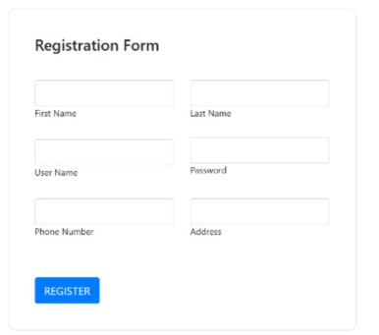

**Fig 1: Register Page**

### Login Page

**Steps:**

After running the application in the net beans

1. Click on **Login** Button in the page
2. Login Page will be displayed
3. Enter the Username
4. Enter the Password
5. Click on **Login** Button

Note: Username and password should be get from the register page itself

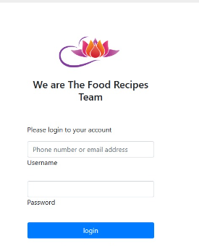

**Fig 2: Login Page**

### Food Review Page

This helps the user to review the food based on the category.

**Steps:**

After running the application in the net beans

1. Click on Login Button in the page

2. Login Page will be displayed

3.Enter the Username

4.Enter the Password

5.Click on **Login** Button

6.Now the **Food review** page will be displayed

7.Select the **Food Category**

8.Select the **Product** related to Food Category

9.Select the **Ingredients** related to Product

10.Now User can the review and health benefits for the food

Note: Username and password should be get from the register page itself

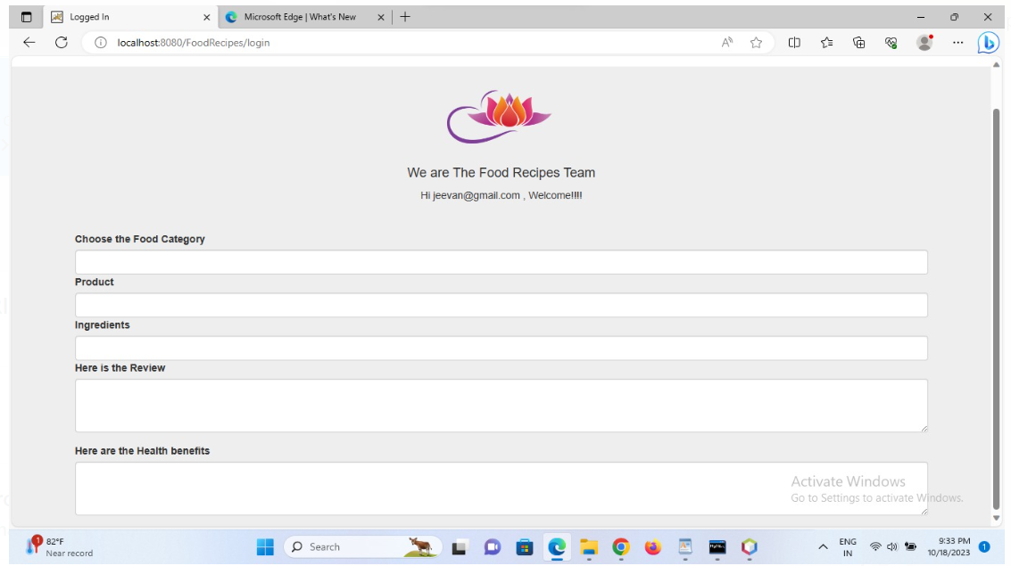

**Fig 3: Food Review Page**

## Troubleshooting & Support

Internal team can troubleshoot the errors while running the application in the console.

### Error / Confirmation Messages

Internal team can troubleshoot the errors while running the application in the console.

1. **User Registered Successfully** -- This means user has register successfully with the valid details.
2. **Error when Registering the User** -- This means user have invalid format of the data while registering.
3. **Incorrect Username & Password -**- This means user have incorrect username or password while login into the application.

Note: Red Indicates Error Message and Green indicates confirm message

### Special Considerations

N/A

### Conclusion

The project food review is for version 1.0. The project discusses all about food review based on the project and ingredients. There is no future version for this project. The project is available in this link. Here we can review and access the application.